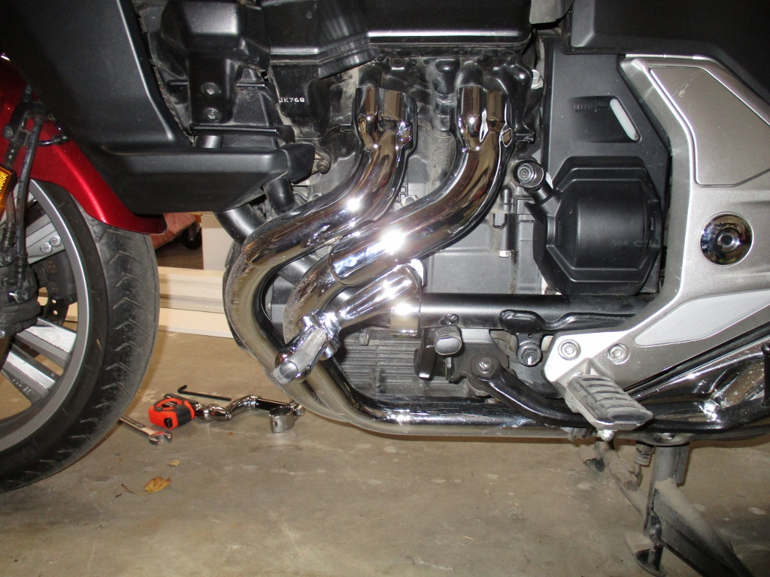
Centerline of pressure by rider
In this position the force from the riders legs are in line with the offset of the peg.
This places the stress on the ½” bolt as a twisting action with the clamp.

